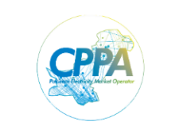 | REQUEST FOR PROPOSAL (RFP)  Procurement of Iron Steel Racks
Central Power Purchasing Agency Guarantee Ltd. (CPPA-G), is a government-owned entity registered under Companies Ordinance 1984, invites eligible firms to submit Technical and Financial Proposals sealed in separate envelopes (Single stage Two Envelope), for “Procurement of Iron Steel Racks”.

Bidding documents (RFP) containing detailed terms and conditions, procedure for submission of bids, bid security, bid validity, opening of bid, evaluation criteria, clarification/rejection of bids etc. for the above services is available for the interested bidders which can be downloaded free of cost from CPPA-G Website, www.cppa.gov.pk .

The sealed bids prepared in accordance with the instructions in the bidding documents, must reach the undersigned on or before 19th January 2024 at 10:00 am & will be opened on same day on 19th January 2024 at 11:00 am at CPPAG Office Islamabad.
Manager (HR&A)
Central Power Purchasing Agency (Guarantee) Ltd.
Address :- Shaheen Plaza, Plot No. 73 West, A.K. Fazl-ul-Haq Road, Blue Area, Islamabad Phone: 111-922-772 (Ext# 167 ) Fax: +92-51-9213617

